10.DFA-EVEN A

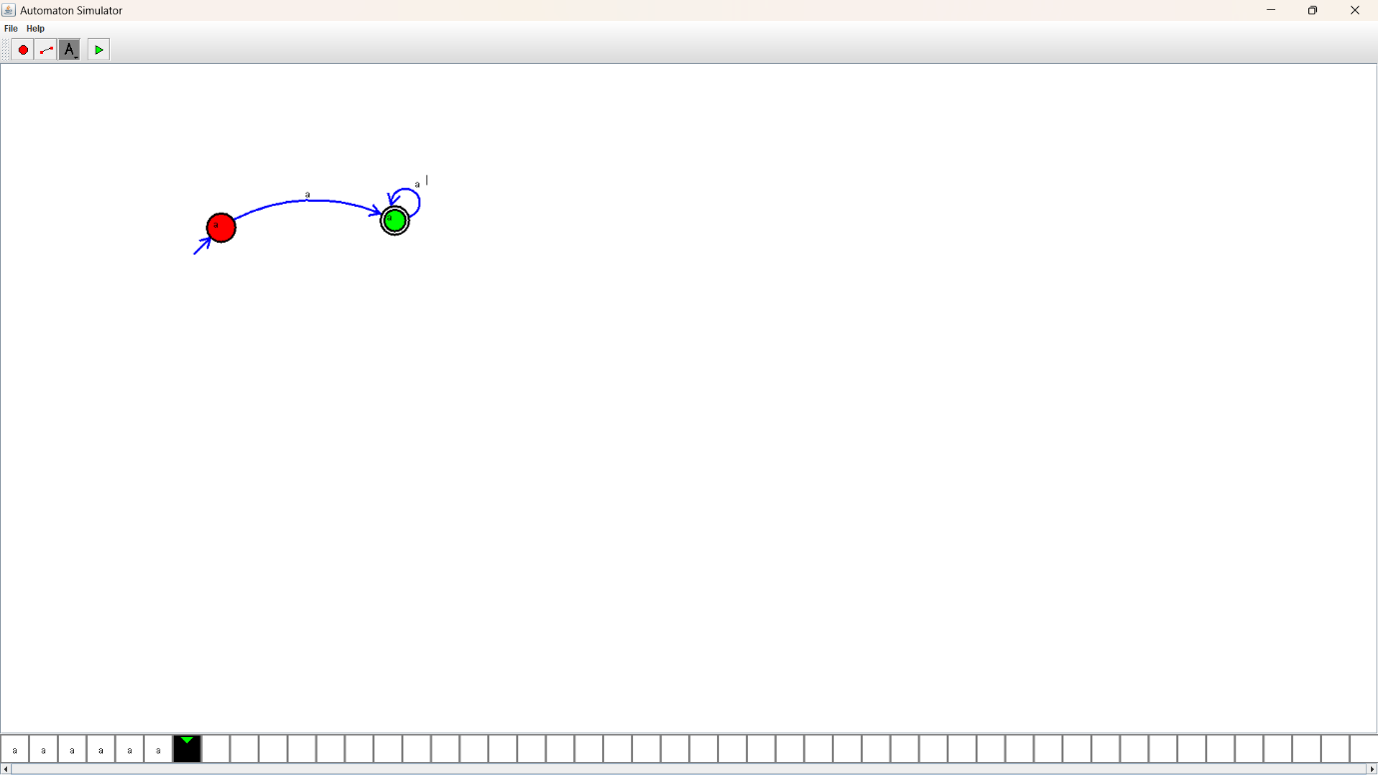Design:

Output:

